OUTERBARK EXHIBITION PROPOSAL
Outerbark Gallery

Introduction 3
Contact Details 3
Features 3
Commission 3
Booking Fees for Exhibition 4
Services 4
Artists Responsibilities 4
Catering 4
Preview / Opening of Exhibition: 2 hours 4
Invitations 4
Exhibition Procedures 5
Documentation 5
Timeline / Checklist 5
Artwork for Exhibition 5
Demount 5
Uncollected Artwork 5
Exhibition Conditions 6
Art Gallery layout 7
PROPOSAL FORM This page only to be returned 9

Introduction
The Lapunyah Art Gallery is a Regional Art Gallery.
It is managed by the Lapunyah Art Gallery Inc. Committee
- It strives to achieve the National Australia Museum Standards for Museums & Art Galleries
- The Director and Volunteer Staff work 2 x 3hrs per month with the Director on call.
It is supported by:
- The Western Downs Regional Council.
- Museum and Gallery Development Officer MDO SIQ
- Museum and Gallery Queensland
- Museums and Gallery Australia

Contact Details
Lapunyah Art Gallery Inc
80-86 Heeney Street,
Chinchilla QLD 4413
Tel: 07 4668 9908
Email: lapunyah@outlook.com
Find us on Facebook
www.LapunyahArtGallery.com
ABN 16 323 422 987 ACNC DGR

Features
The Outer Bark Gallery exhibition area has 20 running metres of exhibition hanging space.
This area not suitable for 3D artworks.
The exhibition space is fitted with tracks, wire and hooks system.
D Rings must be on all works that are to be hung (top of D ring 6cm from top of frame).
These are available at the Art Gallery, if required.

Commission
Commission on sales is 20% on all Exhibition and Merchandise artworks sales
To work out Sale Price - multiply Artist’s Price by 1.25

Booking Fees for Exhibition
Acceptance by the Lapunyah Art Gallery Inc. committee will be subject to a non-refundable booking fee of $25.00 for the Outerbark Gallery, as per Exhibition Policy
All proposals are assessed by the Lapunyah Art Gallery Inc. Committee,
The decision takes into account
- Exhibitions already booked
- Quality of work
- Size
- Available space
- Funding

Services
Service | Assistance | Notice / Requirements
Desktop Services | In-house publishing of,  10 catalogues, Didactics, 30 Invitations plus email copy of invitation | All Paperwork: information is required one month prior to your exhibition to enable preparation and proof reading.  No cost to artist  (Proof reading is mandatory.)
Promotion | Facebook & Website  WDRC Events CCCI Events | No cost to artist
Preview/ Openings | Catering is the responsibility of the artist  The Art Gallery can supply  - Tables and chairs.  - Urn | The Artist is responsible for arranging a person to officially open the exhibition, if desired.

Artists Responsibilities

Catering
- Food – suggest you keep it simple
- Beverage
- Alcohol (if being served)
No drinks or food are to be taken into the Exhibition Area.

Preview / Opening of Exhibition: 2 hours
Alcohol License: no longer required
The Lapunyah Art Gallery will supply Bar Staff if alcohol is served
Alcohol to be consumed within the cordoned off area.

Invitations
The Art Gallery will send invitations to the members of the Lapunyah Art Gallery and WDRC Councillors.
Additional invitations to non-members are the responsibility of the artist.

Exhibition Procedures
Your Proposal will be tabled at the next Lapunyah Management Committee meeting.
The secretary will notify you by mail.
If accepted, you will receive a letter of acceptance and a Booking Fee Invoice for $25.

Documentation
Four months prior to your Exhibition, you will receive the Forms Package with the 6 forms to be completed and returned by date indicated in the Timeline / Checklist, Page 1.
If a group of artists: we will require a list of their names and their contact details to enable us to send the Forms Package to them.

Timeline / Checklist
- By 4 weeks prior, complete & return all Forms for processing (promotion & catalogue preparation)
- By week 3, prior to your Exhibition - Catalogue and wallboard preparation is commenced
- Two weeks prior to your exhibition - Printing of Catalogue and preparation of Didactics

Artwork for Exhibition
Required at the Art Gallery to enable
- Condition Reports
- Curators to plan the installation of your exhibition

Demount
- This will be stated on your Timeline / Checklist Form Page 1 of the Forms Package.
- This is sometime subject to availability of the Volunteers
- Artwork can be collected after 4pm – NB the Art Gallery has very limited storage space
- Sold artwork is available to be collected on sighting of receipt

Uncollected Artwork
- Artwork, not collected within 5 days of demount, will be subject to a storage fee of $10 per item per week
- Artwork not collected within 30 days will be disposed of as per Art Gallery Committee policy.

Exhibition Conditions

Please take time to read the Exhibition Conditions
- All paperwork MUST BE in by the stated times to allow for Promotion & Invitations.
Catalogues, Wall Boards are printed 2 weeks prior to your exhibition.
NO CHANGES will be made after this.
- Installation: The Lapunyah Art Gallery Curator will install all Artwork.
Special installation instructions are to be written with diagram if necessary.

- Condition Reports: The Lapunyah Art Gallery volunteers will perform Condition Reports on all artwork prior to installation.
- Artworks exhibited must be original, and not produced at a workshop.
It is preferable the major part of the exhibition be new work or completed in the past 2 years.
Must not have been exhibited in Lapunyah Art gallery previously.
The gallery reserves the right to not exhibit works which do not meet the gallery ethos.

- No photography will be permitted unless prior written permission has been granted by the artist.
- 2D works to have suitable D rings attached.
  - These are available at the Art Gallery.
  - The top of the D ring is placed 6 cms from the top of the frame.
  - A fee of $20, per artwork, will be charged if the Art Gallery is to put the D rings on your work.
- Identification Label: All artwork MUST HAVE A LABEL attached, lower left-hand corner on the back.
Photographs are NOT acceptable
- Theft of art works: The Lapunyah Art Gallery takes all care but accepts no responsibility for theft.
- Insurance: it is the exhibitor’s responsibility to obtain appropriate insurance cover for losses, before, during and after the exhibition.

- Commission of 20% will be deducted from sales. (Multiply your price by 1.25 to work out Sale Price)
- Freight: Arrangements, costs, and transit insurance are the responsibility of artist.
- Uncollected Artwork - after 5 days, will incur a fee of $10per item per week
after 30 days, will be dealt with at the discretion of the Art Gallery committee.

Art Gallery layout
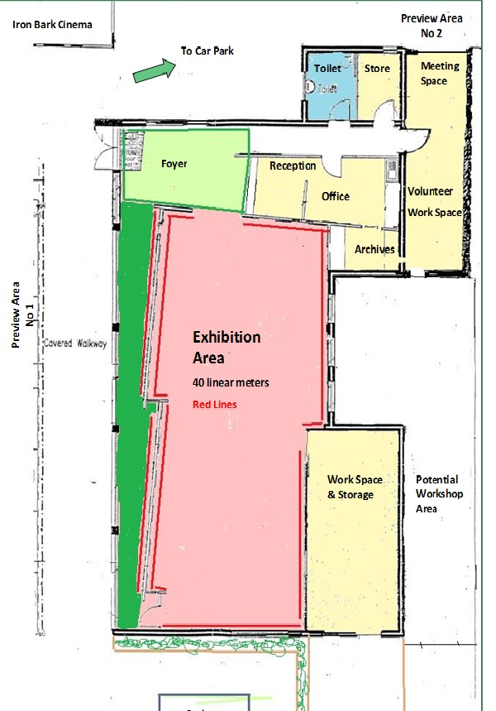

Heartwood Gallery
O
U
T
E
R

B
A
R
K

G
A
L
L
E
R
Y

Leave this page blank for printing

PROPOSAL FORM This page only to be returned

Please complete and return THIS PAGE ONLY to the Art Gallery

The following information is required for the purposes of:
- Application assessment
- Preparation of preliminary publicity material for successful applications.

Artist / Group Name
Contact Person (if group) |  |  | We will require a list of all the artists participating later
Address (postal)
Email
Phone No
Best Time to Contact | AM / PM
Registered for GST | Yes / No | ABN No:
Exhibition Title (Must be stated) | Title: |  | Promotion starts 7 months in advance eg the 6 monthly Exhibition Program
Estimated No. Artworks
(Can be reassessed)
Medium
Describe your Exhibition Theme
This is used for promotional purposes
(50 -100 words)

Will works be for sale | Yes / No
Bank Details - if yes | BSB: |  |  | Account No.
Enclose material that will best represent your work. | Eg Photographs, CD, Current CV
Size of The Outerbark Gallery Area | 20 linear metres or approx. 15-20 2D works  Area not suitable for 3D works

For Office Use Only | Accepted / Declined
Committee’s Comments

